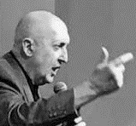  Evangelist Frank Butler |  | Press Release  Invitation to hear Evangelist Frank Butler at:  [Insert your church or venue name]  [Insert the venue street address]  [Insert the date(s) and time(s)]  Jesus Christ the Rock – that never rolls!  Before becoming a Christian Frank was an Australian rock musician who made recordings, TV appearances, and concert tours. He performed with ACDC, Andy Gibb, Bee Gees, Deep Purple, Fats Domino, Little River Band, Freddie Mercury and Queen, and comedian Paul Hogan (Crocodile Dundee).  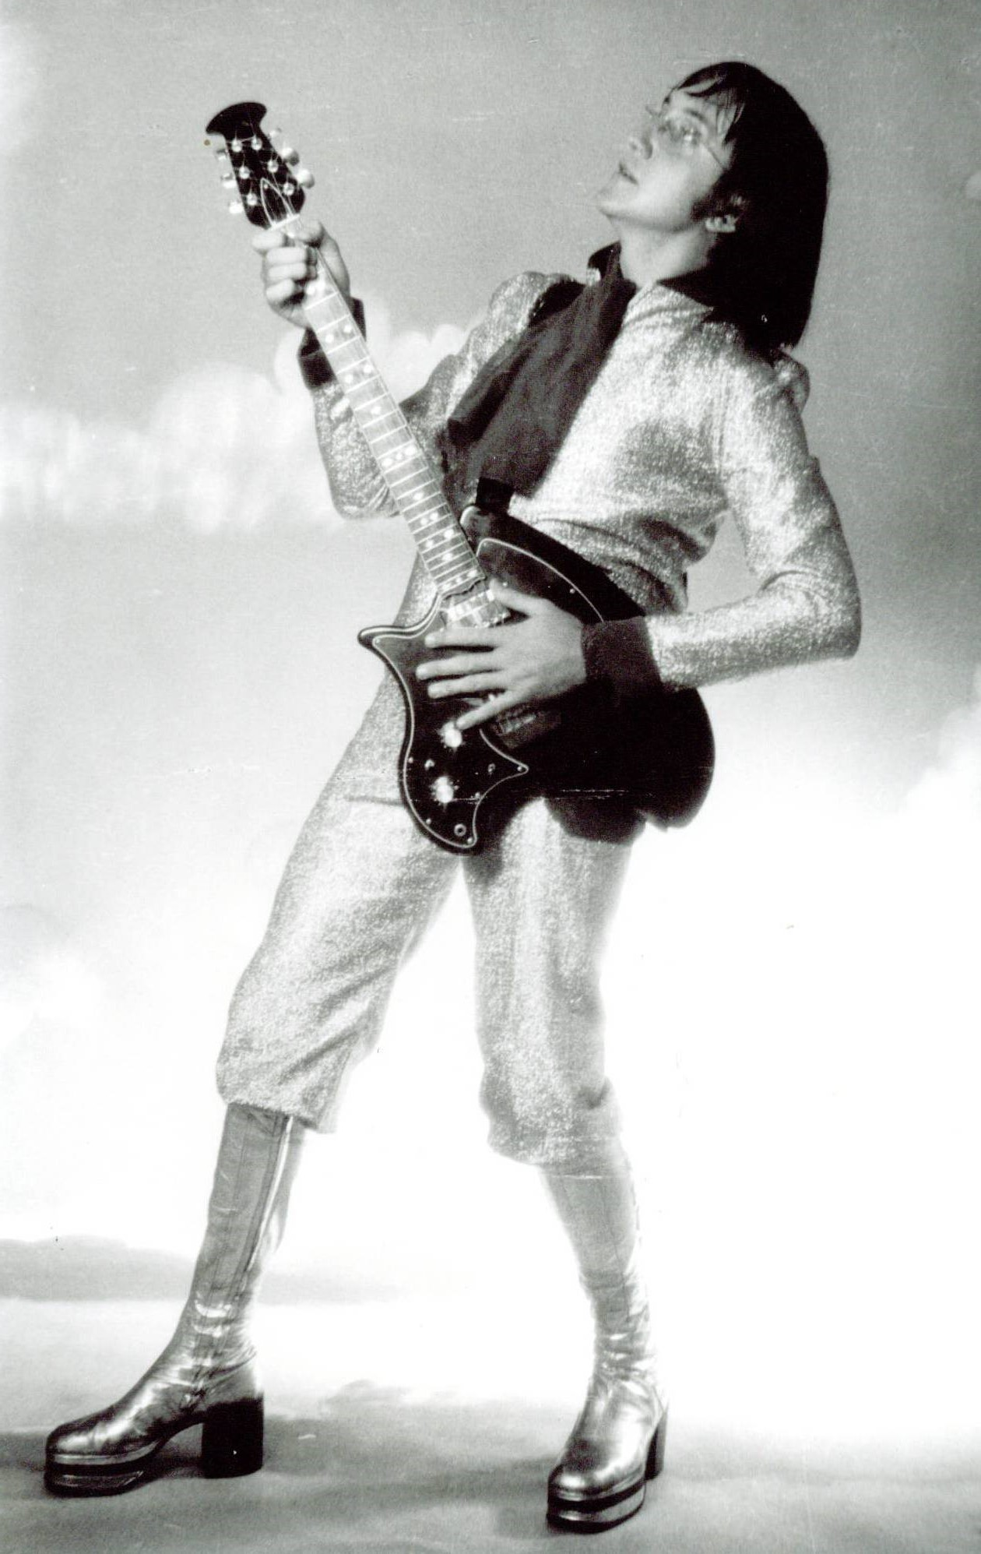  After living in the fast lane and seeing the emptiness in the lives of the rock stars he performed with, Frank realized he was unhappy. He started a quest that meandered through various philosophies, Eastern mysticism, and New Age practices.  Tragedy touched Frank’s life when a friend died in a hotel fire in Sydney, Australia. Frank was overcome with grief and confusion over the senseless death of his friend. He felt there had to be more to life than just living and dying.  A short time later Frank became a committed Christian. Since that time he has taken the “Good News of Jesus Christ” to many nations. Today his ministry headquarters is located in Houston, Texas.  He proclaims the uncompromising message of God’s love and miraculous power in Word and song. Countless people have found a relationship with Jesus Christ and received healing and other blessings in his services.  At one time Frank lived for “rock & roll” but now he lives for Jesus Christ, “The Rock” – that never rolls!  Visit Frank’s website at www.frankbutler.org

SERVICES Hosted bY:
[Insert your organization’s logo and name]

CONTACT
PHONE:
[Insert your phone number]

WEBSITE:
[Insert your website]

EMAIL:
[Insert your email]

